Zion Memorial
Bollinger’s Chapel

The Shepherd
Third Edition – Volume 5
October, 2022

Words from the Intern
Greetings, everyone! Things have certainly changed in these few months, especially the cool temperatures now hitting North Carolina! Pretty soon it will be Halloween, so start stocking up on candy before it all runs out!! I must say that I am really enjoying my time with you both. I have taken on more duties, such as becoming the interim song leader at Bollinger’s Chapel UMC and preaching my first sermon at Zion Memorial last Sunday! The Lord is truly keeping me busy, and I couldn’t ask for a better place to do my internship this semester.
In this newsletter, I’d like to highlight something that not many people talk about anymore: the beauty of our world and why it came to be. The time is soon approaching for the leaves to change colors, the temperature slowly decreases, and warm cocoa is sipped next to a roaring fire. God really must have had His hands full when He created the universe, especially our planet and everything in it. He took time to create every single animal, fish, insect, and tree. He made the stars in the sky, and the soil on the ground. He made the sea glisten under the sunlight, and the sky light up with beautiful colors in the morning and night. Most importantly, He took time to create us, His children. He did these things because He loves us with all His heart. He lifts us up when we are down and guides us on our path in life. To put it simply, let me quote a verse from Psalms: “This is the Lord’s doing. It is marvelous in our eyes” (Psalm 118:23). His love for us is a perfect reminder that we are never alone in this world, for our Father is right by our side. My mentor, Dr. Robert Kerr, told me that after concluding a church service, an elderly woman came up to him and said that he wasn’t the only person at the pulpit. Confused, he asked what she meant, and she claimed to have seen multiple people next to him as he preached. A guardian angel perhaps? Or maybe family members that have long passed, coming to show support? Either way, the message I want to emphasize is that wherever you are in life, no matter what kind of a person you are, GOD LOVES YOU! Never stop being who you are, for it puts a smile on God’s face. May you all have a wonderful month. You are all in my prayers.
Blessings,
-Sethu

This Photo by Unknown Author is licensed under CC BY-NC
This Photo by Unknown Author is licensed under CC BY-NC

October Birthdays October Anniversaries
1st – Todd Gilliland
2nd – Helen Starnes Ryan & Melissa Childers
18th – Kim Spann
19th – Tom Shuping
24th – John Seitz
24th – Jeremy Spann

Prayer Requests
Always all members of both Bollinger’s Chapel and Zion Memorial with extra prayers for:
Bollinger’s Chapel
Ronnie & Ann Barus, Ronnie Dale, Danny & Regina Alexander, Irene Yelton, Marcie Bowman, Misty Pagent, Lisa Miller, Trisha, Libby Meadows, Sherri, Betty Johnson, Bobbie McEntire, Mary Gordon, Ryan Phillips, Elaine Phillips, Tim Stafford, Danni Furgenson, David Pickard, Bill & Ruby Duncan, William Fowler, Dolly Maltba, Regina Alexander’s Sister-in-Law, Janice Willis, Melissa Clark, Tony Day, Jada Sadler, Dylan Webb, Betty Brown, Jackie Bowman, Ruth Murphy, Rick Ogle, Jody Stafford, Ann Robinson, Deb Wilson, George Williams, Francis Shull, Frank Gilliland, Phil Ramsey, Linda Kiddy, Cathy Williams Marshall, Heather Carswell, Tiffany Temple, Bruce Weaver, Mandy Norman

Zion Memorial

Maxine & Jerry Propst
Virginia Franklin
Laura Jarrett
Bill Berry
Johnathan Moore
George & Terry Davanelos
Don & Clara Hunt
Celia Anderson
Cathy Williams Marshall
Dale & Rachael Cozort
George & Gaile Williams
Roy Barus
Tina Baker
David & Barbara DeVries
Jennifer Abee Smith
Camdyn Abee
Mary Jane Miller
Vee McCall
John & Lynne Seitz
Gene Turnmire
Nina Hartman
Preston Lang
Nancy Riddle
Keith Palmer
David & Jennie Allred
Glendora Edwards
Reba Pritchard
Colin McCleary
Sue Ann Sperling

*** Pray for our Nation and all branches of our millitary, police, firemem, medical personnel and all other essential workers.

***Please turn in to Doris Pickard any Newsletter announcements of upcoming events and all other items you which to have placed in the newsletter by the 3rd Sunday of each month. Please call my cell if you have someone that needs to be added to or removed from the prayer list. Thank you, Doris
Church office hours are on Fridays.
This Photo by Unknown Author is licensed under CC BY-SA
Each month that has 5 Fridays, the Pastor will not be in the office on one of the
Fridays during that moth.
Zion, Fridays - 9:00 AM - 12:00 PM Church phone # 828/437-3444
Bollinger’s, Fridays – 1:00 PM – 4:00 PM & til meals are delivered.
Church phone # 828/368-0410
You can reach Steve Pickard by phone on or by email: psstppckrd@aol.com his cell # 828/244-2845 or
Doris Pickard at 828/234-9661, email: drlgood@aol.com

Special Announcements

Meals on wheels continue to be served on the 2nd and 4th Fridays of each month. Please contact Jean Childers if you wish to help by serving or make donations, and if you know of someone who could benefit from receiving a meal.

All are encouraged to continue to wear MASKS. Thank you!
Bollinger’s Chapel Announcements
Beginning, Weekly Bible Study at Bollinger's Chapel at 1-2 PM, every Friday. Lead by Charles McGee, A study on Corinthians.

- Meals on Wheels on 2nd and 4th Fridays of each month starting about
2 PM in the kitchen.
- Pregnancy Care Center – Bollinger’s will once again start collecting
items for children 1 month to 2 years old to donate to the
Pregnancy Center. Bring your items and place in a box located in
the Narthex.
- Food donations can be place in the narthex.
- Administrative Broad meeting on October 2, 2022 at 3 PM in the
sanctuary
- A snack donation box for the Fire/Police Department’s day sift is located
in the Narthex.

Zion Memorial’s Announcements

- Bring non-perishable food items for B.U.C.M..
- 165 lbs of food was donated to B.U.C.M. during September
- You are Invited to Bible Study at Bollinger’s Chapel, every Friday at 1PM.
- Oct. 7th at 10 AM Administrative Board Meeting in the Sanctuary.
- Collecting Cleaning Supplies for the Homeless shelters.
- Church luncheon the last Sunday of each month to celebrate birthdays
and anniversaries for the month.
This Photo by Unknown Author is licensed under CC BY-SA-NC
Come join us and bring your favorite
dish to share.
- Website has been updated
www.zionmemorialmorganton.org
Please visit our website and listen to
the audio of Sunday’s service. Services
will be added by noon on Mondays
barring there are no technical issues. Newsletters containing announcements can also be visited on the site as well. Hope you enjoy. We would appreciate your feedback.

Members of both Zion and Bollinger’s
Are Invited to have
Coffee & Pastries with Pastor Steve
every Friday morning
from 9:30 to 11 AM at Zion Memorial UMC

All Saint’s Day
Recognition Sunday

Zion Memorial’s Day will be on Sunday, October 30, 2022
Bollinger’s Chapel will be on Sunday, November 2, 2022

A 3 X 4 ft. board will be provided for you to place a picture of your loved one and their name. As we take time to remember and as you place your loved one’s picture on the board feel free to share your thoughts and a special memory with us. After our time remembrance we will share a meal together. The Memory Board will then be place in each church’s Prayer Room.

Saints of the Church
Memory Board

Joint Charge Conference for Bollinger’s and Zion
Will be on Nov. 13, 2022 at 3 PM
Location is Abernathy UMC in Rutherford College
It will be joint with 5 other Methodist churches in our Missional Network.

Internet Virus Alert
A few members have run into those terrible computer viruses that flash on the monitor saying, Notice from Microsoft your computer has been locked due to some ???? Attack on your system and to correct the problem they tell you to call a number or click the button below!!!
STOP!!!!
DON’T DO THAT, IT’S THE VIRUS
Do the following as soon as possible.
- Unplug you’re your modem & router cables and power cords from the wall outlets and other connected equipment.
- Unplug your computer and/or laptop
- Turn off your computer/laptop or smartphone for a few hours
- If your device will not turn off, you’ll need to close the lid and let the battery run down.
- Call your tech company such as Best Buy or Staples explain what happened and schedule a device check/cleanup appointment.
- Following these steps may help solve the problem or at least stop the virus from getting access to your personal information until you are able to get it fixed.
- Internet providers do provide security & virus protection, but nothing is ever enough. It’s good to have an additional security program but there it’s still not 100% guaranteed. There are many protection plans available for purchase. The one I use is Webroot through Best Buy. Again, nothing is a 100%.

Hopefully this bit of information will help you
if ever needed.

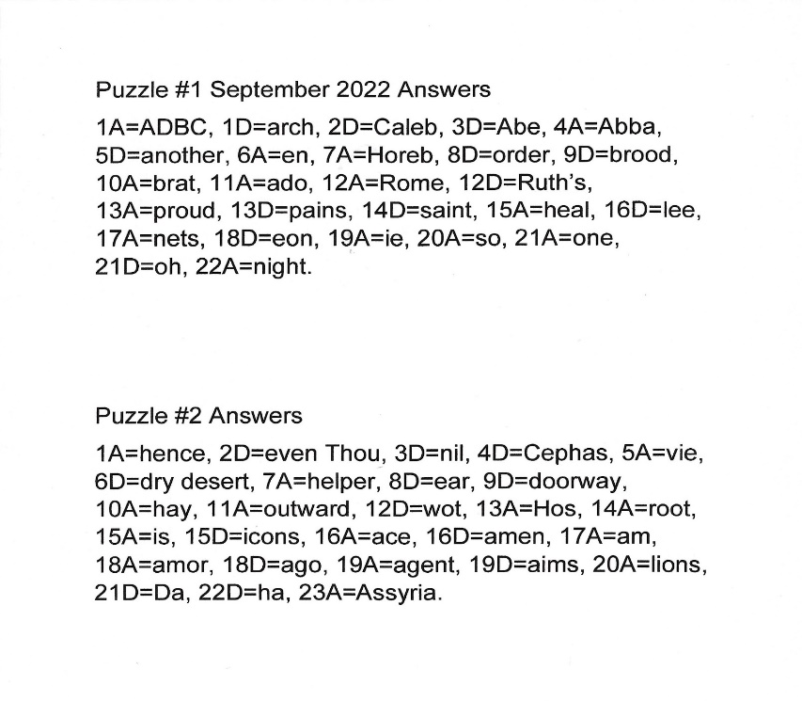
SeptemberPuzzle Answers

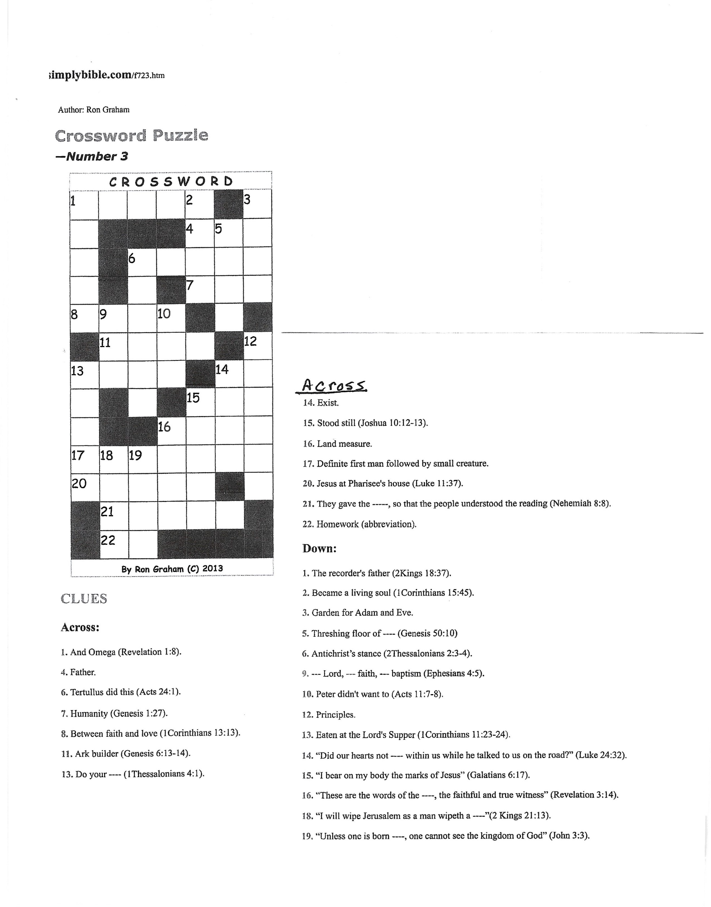
October Puzzles
This Photo by Unknown Author is licensed under CC BY

This Photo by Unknown Author is licensed under CC BY-SA-NC

As I wrap up this months Newsletter I want to take a minute to
thank both churches for all the beautiful birthday cards and their supportive messages and a special thank you to my husband, Steve who surprised me with an overnite outting to Flat Rock, NC. If you haven’t been there, you should give it a look. The Lodge at Flat Rock is beautiful and the employees are great. We had a restful trip and enjoyed a play at the Flat Rock Playhouse.
The best part however, was spending time together with

NO COMPUTERS!!!!

Love you all, Doris

