Zion Memorial
Bollinger’s Chapel

The Shepherd
Third Edition – Volume 6
November, 2022

Words from the Intern
Greetings, everyone! I hope your October has been going well! Hard to believe that Halloween is right around the corner, and soon it will be November!! I love this part of the year, as the leaves turn beautiful shades of orange and red. Pumpkin patches are sprouting up everywhere, and corn mazes are always a delight for kids to explore. Personally, there’s nothing I enjoy more than relaxing at home, wrapped up in a blanket and sipping a cup of hot tea. This world is full of such amazing things, and we have the good Lord to thank for all of them! Reminds me of the song “How Great is Our God” and how each day of life is truly a blessing. As November comes up shortly, we are reminded of that most sacred holiday: Thanksgiving. The time when families and friends get together and share a meal that has been around since the Pilgrims discovered our continent over four hundred years ago. It is a time to be thankful for the things we have, the people in our lives, and the experiences God places in our lives daily. And most of all, we must be thankful for the delicious food we get to eat, pumpkin pie and all!!
So, in preparation for Thanksgiving, I’d like you to take a moment and write down a few things you are thankful for. Then share them with your families or wait until Thanksgiving and save it for a surprise! Either way, I know your hearts will be touched, and lives will be blessed because of this act of kindness. I am so thankful for every one of you. I have missed spending time with y’all at church these past few Sundays due to some health issues, but I am gradually feeling better. Let me end this message with a quote I found symbolizing the importance of Thanksgiving. “Life is a celebration. Consider everything that makes you happy as a gift from God and say thank you”.
Blessings and love to you all,
-Sethu
This Photo by Unknown Author is licensed under CC BY-NC
This Photo by Unknown Author is licensed under CC BY-NC

November Birthdays November Anniversaries
6th – Cindy Fletcher 19th – David & Barbara DeVries
6th – David Duncan 22nd – Ronnie & Ann Barus
16th – Elijah Pritchard
28th – Lynne Hallyburton

Prayer Requests
Always all members of both Bollinger’s Chapel and Zion Memorial with extra prayers for:
Bollinger’s Chapel

Ronnie & Ann Barus, Ronnie Dale, Danny & Regina Alexander, Irene Yelton, Marcie Bowman, Misty Pagent, Trisha, Libby Meadows, Sherri, Betty Johnson, Bobbie McEntire, Mary Gordon, Ryan Phillips, Elaine Phillips, Tim Stafford, Danni Furgenson, Bill & Ruby Duncan, William Fowler, Dolly Maltba, Regina Alexander’s Sister-in-Law, Janice Willis, Melissa Clark, Tony Day, Jada Sadler, Dylan Webb, Betty Brown, Jackie Bowman, Ruth Murphy, Rick Ogle, Jody Stafford, Ann Robinson, Deb Wilson, Gaile Williams, Francis Shull, Frank Gilliland, Phil Ramsey, Linda Kiddy, Cathy Williams Marshall, Heather Carswell, Tiffany Temple, Bruce Weaver, Maundy Norman, Junie Barret-friend of Angie, Betty Brown

Zion Memorial

Maxine & Jerry Propst Virginia Franklin
Laura Jarrett Bill Berry
Johnathan Moore George & Terry Davanelos
Don & Clara Hunt Celia Anderson
Cathy Williams Marshall Dale & Rachael Cozort
Gaile Williams Roy Barus
Tina Baker David & Barbara DeVries
Jennifer Abee Smith Mary Jane Miller Vee McCall John & Lynne Seitz Gene Turnmire Nina Hartman Preston Lang Nancy Riddle Keith Palmer David & Jennie Allred Glendora Edwards Reba Pritchard Colin McCleary Sue Ann Sperling

*** Pray for our Nation and all branches of our millitary, police, firemem, medical personnel and all other essential workers.

***Please turn in to Doris Pickard any Newsletter announcements of upcoming events and all other items you which to have placed in the newsletter by the 3rd Sunday of each month. Please call my cell if you have someone that needs to be added to or removed from the prayer list. Thank you, Doris
Church office hours are on Fridays.
This Photo by Unknown Author is licensed under CC BY-SA
Each month that has 5 Fridays, the Pastor will not be in the office on one of the
Fridays during that moth.
Zion, Fridays - 9:00 AM - 12:00 PM Church phone # 828/437-3444
Bollinger’s, Fridays – 1:00 PM – 4:00 PM & til meals are delivered.
Church phone # 828/368-0410
You can reach Steve Pickard by phone on or by email: psstppckrd@aol.com his cell # 828/244-2845 or
Doris Pickard at 828/234-9661, email: drlgood@aol.com

Special Announcements

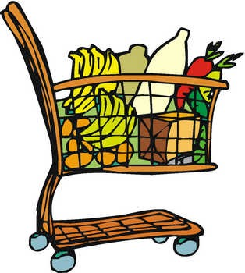
Meals on wheels continue to be served on the 1st and 3rd Fridays of November & December. Please contact Jean Childers if you wish to help by serving or make donations, and if you know of someone who could benefit from receiving a meal.
All are encouraged to continue to wear MASKS. Thank you!
Steve and Doris will be out of town from November 7th through November 12th. If you need us please call. We can easily return from vacation at anytime.
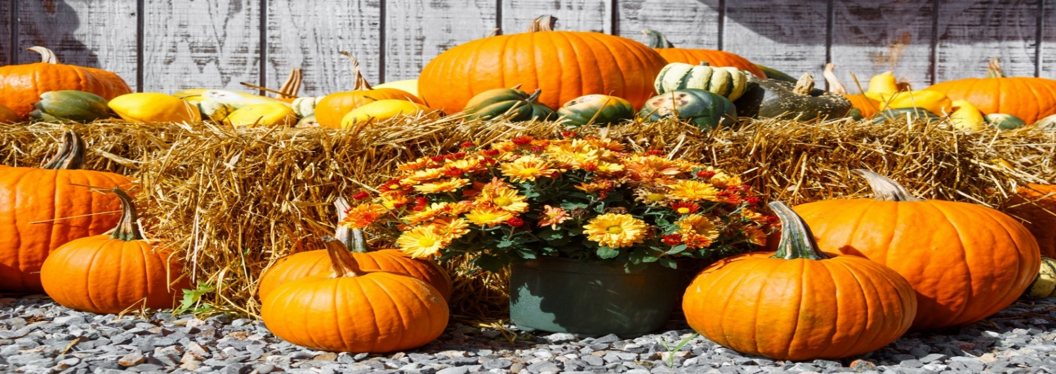
Bollinger’s Chapel Announcements
Beginning, Weekly Bible Study at Bollinger's Chapel at 1-2 PM, every Friday. Lead by Charles McGee, A study on Corinthians.

- Meals on Wheels on 1st and 3rd Fridays of November & December
starting about 2 PM in the kitchen.
- Pregnancy Care Center – Bollinger’s will once again start collecting
items for children 1 month to 2 years old to donate to the
Pregnancy Center. Bring your items and place in a box located in
the Narthex.
- Food donations can be place in the narthex.
- A snack donation box for the Fire/Police Department’s day sift is located
in the Narthex.

Zion Memorial’s Announcements

- Bring non-perishable food items for B.U.C.M..
- You are Invited to Bible Study at Bollinger’s Chapel, every Friday at 1PM.
- Collecting Cleaning Supplies for the Homeless shelters.
- Church luncheon the last Sunday of each month to celebrate birthdays
This Photo by Unknown Author is licensed under CC BY-SA-NC
and anniversaries for the month.
Come join us and bring your favorite
dish to share.
- Website has been updated
www.zionmemorialmorganton.org
Please visit our website and listen to
the audio of Sunday’s service. Call the
church and leave a message saying
you listened to the service and your name, and you’ll be added to that Sunday’s attendance. Services will be added by noon on Mondays barring there are no technical issues. Newsletters containing announcements can also be visited on the site as well. Hope you enjoy. We would appreciate your feedback.

Members of both Zion and Bollinger’s
Are Invited to have
Coffee & Pastries with Pastor Steve
every Friday morning
from 9:30 to 11 AM at Zion Memorial UMC

All Saint’s Day
Recognition Sunday

Bollinger’s Chapel will be on Sunday, November 6, 2022

A 3 X 4 ft. board will be provided for you to place a picture of your loved one and their name. As we take time to remember and as you place your loved one’s picture on the board feel free to share your thoughts and a special memory with us. After our time of remembrance, we will share a meal together. The Memory Board will then be place in each church’s Prayer Room.

Saints of the Church
Memory Board

Joint Charge Conference for Bollinger’s and Zion
Will be on Nov. 13, 2022, at 3 PM
Location is Abernathy UMC in Rutherford College
It will be joint with 5 other Methodist churches in our Missional Network.

October Puzzle Answers

1A=Alpha, 1D=Asaph, 2D=Adam, 3D=Eden, 4A=Dad, 5D=Atad, 6A=orate, 6D=oppose, 7A=man, 8A=hope, 9D=one, 10D=eat, 11A=Noah, 12D=tenets, 13A=best, 13D=bread, 14A=be, 14D=burn, 15A=sun, 15D=scars, 16A=acre, 16D=Amen, 17A=adamant, 18D=dish, 19D=anew, 20A=diner, 21D=sense, 22A=HW.
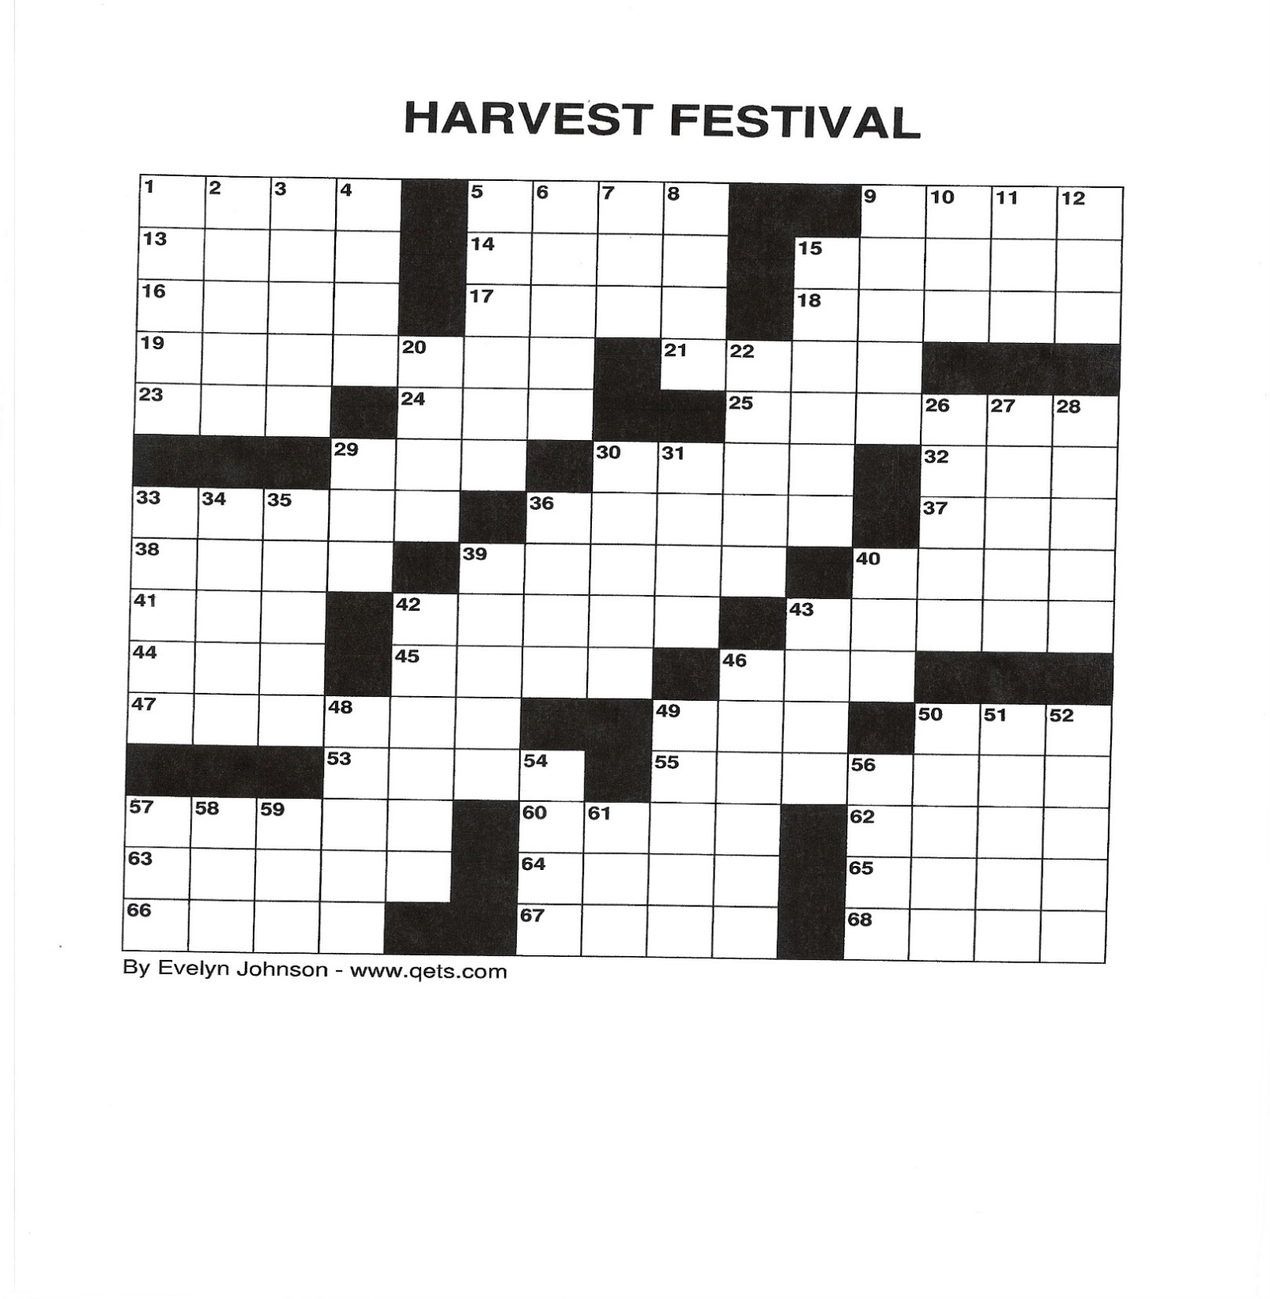
November Puzzles

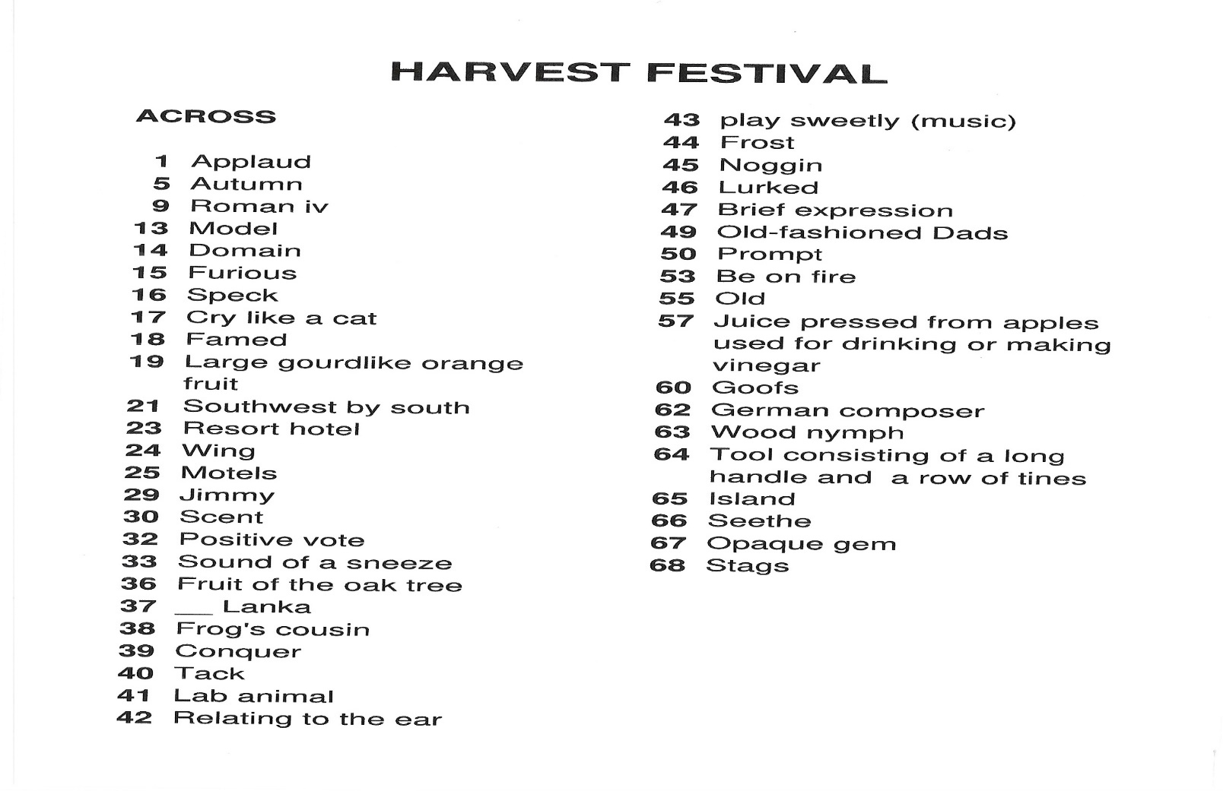
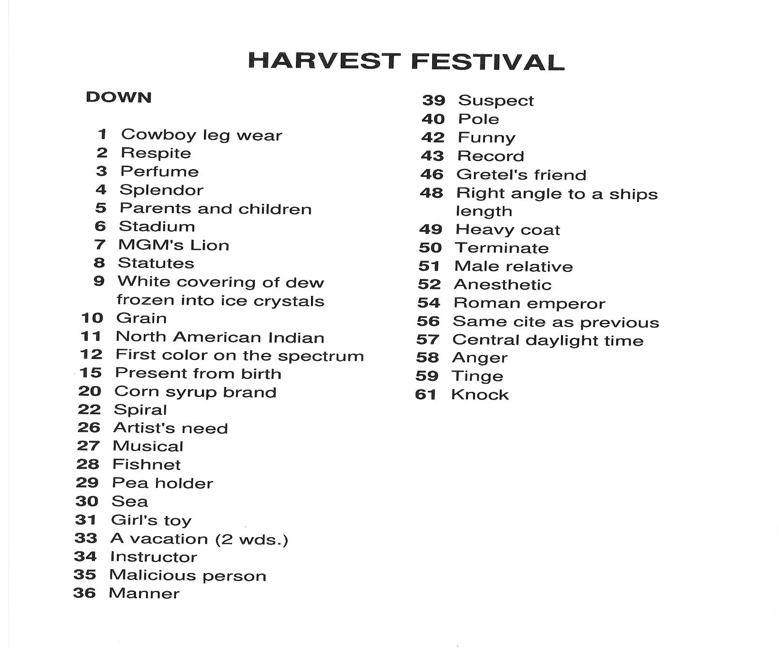
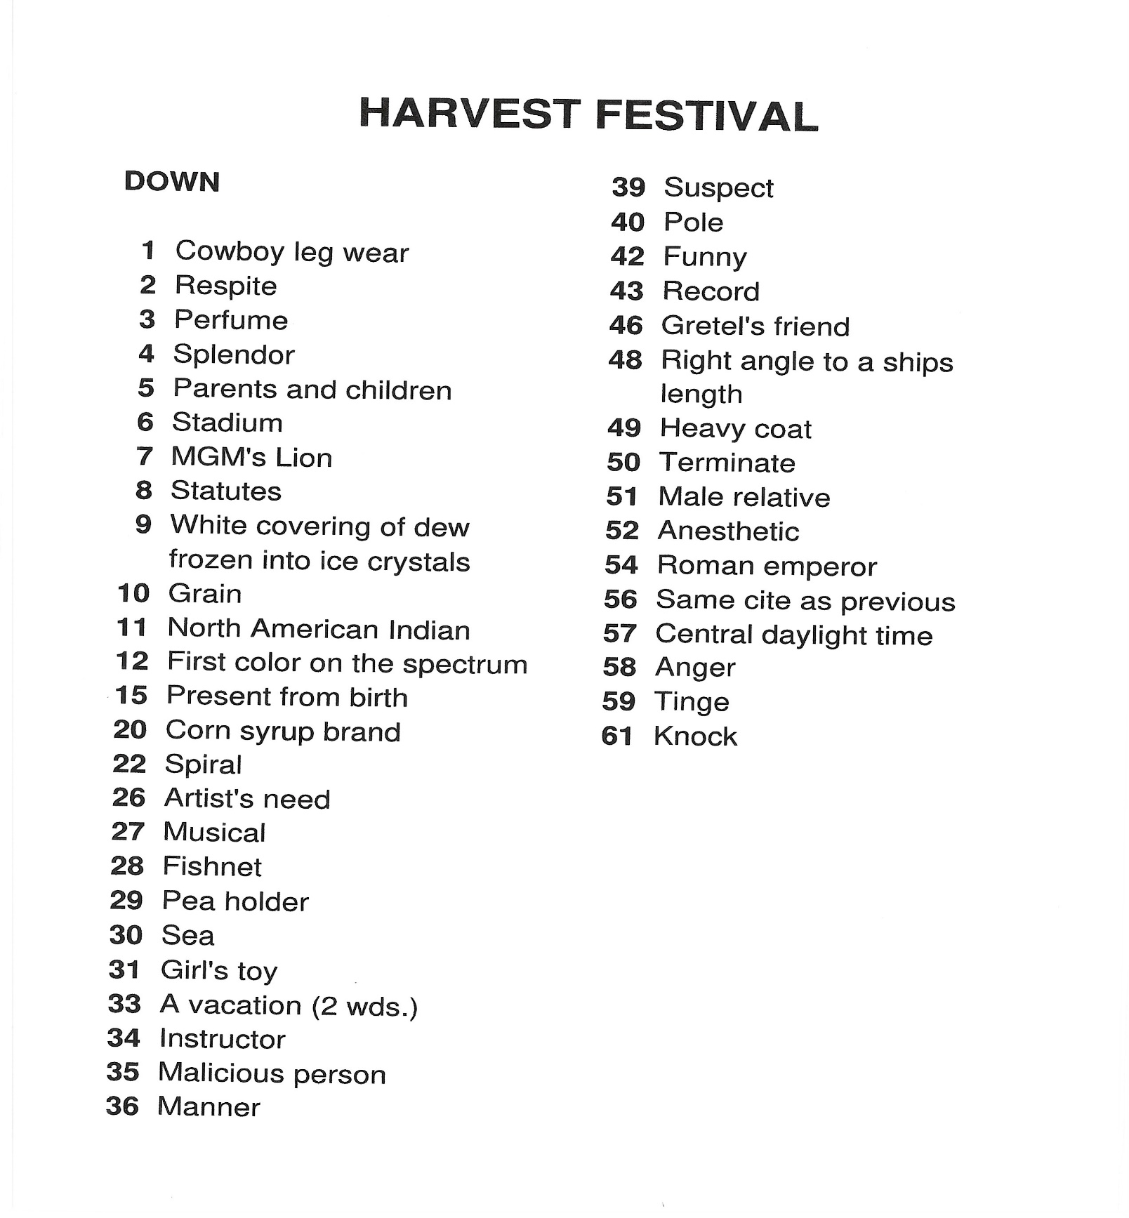

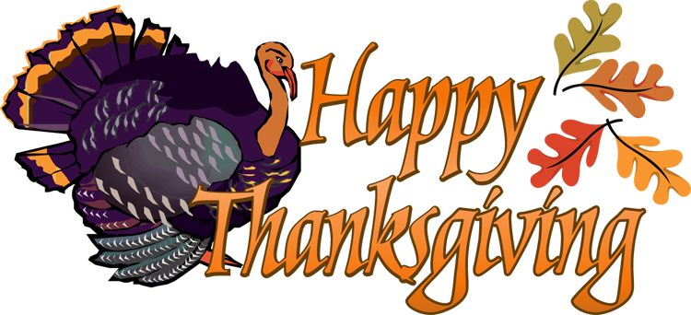
This Photo by Unknown Author is licensed under CC BY-NC

