Zion Memorial

Bollinger’s Chapel

The Shepherd

**Fifth Edition – Volume 1**

**June 2024**

**PAST0R’S NOTES**

**If April showers bring May flowers, then what can we say about May rains? For anyone who has a rain gauge one can see that we have been inundated with showers. Here is another story! A few years ago, after months of no rain, I was driving around in my car, and I would see bumper stickers that said… “pray for rain.” Boy, there is just no pleasing us, is it? It just seems it’s our nature to find something to worry or complain about all the time, and yet what does the scripture tell us about worry? In the Book of Philippians, Paul writes these words: “Do not be anxious about anything, but in everything by prayer and supplication with thanksgiving let your requests be made known to God. And the peace of God, which surpasses all understanding, will guard your hearts and your minds in Christ Jesus.” Now, none of us would be wise to take in today’s worldly situation without concern, God expects His people to use their gifts in making our world better by bringing His love and “Light of Truths” into this world, but the overall thrust of Paul’s message is “Don’t sweat the small stuff!” Let’s put our focus on things in this world that can make a positive difference in the lives of people by telling them about a risen Savior who loves them and wants them to be at peace with the world and themselves and to just do one simple thing………trust Him to deal with the problems of the world and He does this by our sharing not only of His wisdom, but of His Love through you and me! So, let’s just sit back, thank Him for our beautiful weather (rain or shine) and continue on with our sacred mission of being His disciples in our world today!**

**In His Service,**

**Stephen R. Pickard**

**June Birthdays June Anniversaries**

**3rd – Dolly Maltba 14th – Tom & Stella Shuping**

**7th – Alex Childers 25th – Bruce & Michelle Weaver**

**10th – Nina Saunders 30th – Jerry & Maxine Propst**

**12th – Maxine Propst**

**29th - Angie Price**

**30th – Betty Brown**

**Prayer Requests**

**Bollinger’s Chapel**

**Ryan Abee**

**Frances Shull**

**The Childers Family**

**Ann Barus**

**Elaine Phillips & Family**

**Don Hunt**

**Bruce Weaver**

**Danny & Regina Alexander**

**Emma & Alaina Alexander**

**Mary Gordan**

**Betty Brown**

**Keith Bishop**

**Linda Helms**

**Herman Messer**

**Jordan Ferrell**

**Brandy Garrison**

**Dolly Maltba**

**Annie Mae Whisnant**

**Melba Carroll**

**Wanda Reep**

**Imogene Keaton**

**Tina Neal**

**Lisa Hoyle**

**Mary Jane & William Lea**

**Bill King – Newell’s son**

**Leigh Ann Gantt**

**Charlene Hutson**

**Dave – heart catheterization**

**Lynn Reid Family**

**Randy Grigg Newell’s son-in-law**

**Karen Seagle**

**Bill Orders-Cancer**

**Granville Freeman**

**Essential Workers Grace Hospital**

**People in Ukraine**

**Taylor Lail**

**Brenda McClellan**

**Tom Robinson**

**James McEntire**

**Bobbie McEntire**

**Nancy Sermons**

**Keith Palmer**

**Kelly Bradshaw**

**Dwayne Elliott**

**Kim Begley**

**Zion Memorial**

**Jerry & Maxine Propst**

**Bill Berry**

**George & Terry Davanelos**

**Jennifer Abee**

**Dale Cozort**

**Daphne Mozeley**

**Freida Yates**

**John & Lynne Seitz**

**Keith Palmer**

**Gary Grigg**

**Laura Jarrett**

**Glendora Edwards**

**Robert Abernathy**

**Bruce Weaver & Family**

**Don & Clara Hunt**

**Ella Reece**

**Reba Pritchard**

**Virginia Franklin**

**Robert Rector**

**Sundae Bowzer**

**Preston Lang**

**Tina Baker**

**Peggy Standefer**

**Lynn Reid Family**

**Theo Hallyburton**

**Sue Ann Spurling**

**Lynn Hallyburton**

**Justin & Rhonda (homeless)**

**Our Nation & all branches of our military, police, firemen, medical personnel, and all other essential workers. Pray for Ukraine and to the end of Russian terrorism. Pray for the people of Israel & Gaza.**

**The churches of Bollinger’s Chapel and Zion Memorial express their sympathy to Jim Reid upon the death of his wife Lynn and to Lynn’s, 3 children and grandchildren. Lynn Reid will be remembered by all of us. She was a tallented organist and pianoist who served both churches. We greatly appreciated her music leadership, beautiful voice and vivacious smile. Her strong faith in our Lord was an example f or all of us.**

**Lynn, we love you!!!!**

**Church office hours are on Fridays.**



[This Photo](http://thebyronicman.com/2011/10/08/the-vision-to-be-visionary-about-visions/) by Unknown Author is licensed under [CC BY-SA](https://creativecommons.org/licenses/by-sa/3.0/)

**Each month that has 5 Fridays, the Pastor will not be in the office on one of the**

**Fridays during that month.**

Zion, Fridays - 9:00 AM - 12:00 PM Church phone # 828/437-3444

Bollinger’s, Fridays – 1:00 PM – 4:00 PM & til meals are delivered.

Church phone # 828/368-0410

You can reach Steve Pickard by phone on or by email: psstppckrd@aol.com his cell # 828/244-2845 or

Doris Pickard at 828/234-9661, email: [drlgood@aol.com](mailto:drlgood@aol.com)

**Bollinger’s Chapel Announcements**

**Meals on wheels continue to be served on the 2nd and 4th Fridays of each month. Meal preparation will begin around 1 PM. Please contact Jean Childers (828/604-1022) if you wish to help by serving or make donations, and if you know of someone who could benefit from receiving a meal. Please let us know any meals suggestions you may have.**

**Meals on Wheels Menu for June 2024,**

**June 14th – Hotdogs, baked beans, chili, slaw, onions, fruit or dessert**

**June 28th – Sub sandwiches, lettuce, tomato, onions, chips & dessert**

* **Meals on Wheels food preparation starts at about 1:30 pm in the fellowship hall kitchen,**

**on 2nd & 4th Fridays.**

* **Pregnancy Care Center – Bollinger’s will once again start collecting items for children 1 month,**

**to 2 years old to donate to the Pregnancy Center. Bring your items and place in a box, located**

**in the Narthex.**

* **Food donations can be placed in the narthex.**
* **Please check Bollinger’s Chapel UMC, Facebook page. We are now**

**live-streaming Sunday Worship. Please call a Church member and let us know you**

**watched our service. Feel free to add any comments you wish. This will help us improve our services.**

**May Facebook views = 213**

**Zion Memorial’s Announcements**

* **Bring non-perishable food items for B.U.C.M.**
* **Collecting Cleaning Supplies for the Homeless shelters.**
* **Website is:** [**www.zionmemorialmorganton.org**](http://www.zionmemorialmorganton.org)



[This Photo](https://technofaq.org/posts/2017/07/6-reasons-why-you-need-to-update-your-cms/) by Unknown Author is licensed under [CC BY-SA-NC](https://creativecommons.org/licenses/by-nc-sa/3.0/)

**Please visit our website and click the link**

**or visit our livestream on Facebook**

**and Watch Sunday’s Worship Service.**

**You can Search Facebook for**

**Jerry Propst and a, Picture of Zion**

**Memorial. Then, at 11 AM on Sunday mornings and watch the service live.**

**Then call the church or leave a comment on Facebook or our webpage saying that you**

**listened to the service and your name, and you’ll be added to that Sunday’s attendance. Feel free to add any comments. This will help us to improve our services. The service link will be added by noon on Mondays or Sunday evenings, barring no technical issues to the website. Newsletters containing announcements can also be visited on the site as well. Hope you enjoy. We would appreciate your feedback.**

**May Facebook views = 100**

***Please turn in to Doris Pickard any Newsletter announcements of upcoming events and all other items you wish to have placed in the newsletter by the 3rd Sunday of each month. Please call my cell if you have someone

that needs to be added to or removed from the prayer list. Thank you, Doris

**Puzzle Answers for April & May**

**June 16th**

**June 2024 Crossword Puzzle**

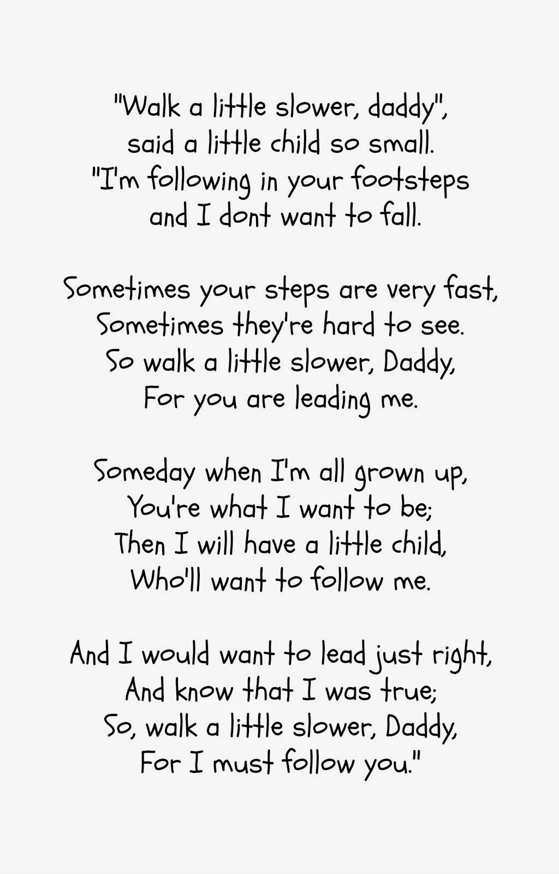

[This Photo](https://www.globalawareness101.org/2021/06/happy-fathers-day.html) by Unknown Author is licensed under [CC BY](https://creativecommons.org/licenses/by/3.0/)

